DATE: MAY 14, 2018

FROM: MITCH SCHNEIDER/BARI LIEBERMAN—MSO PR

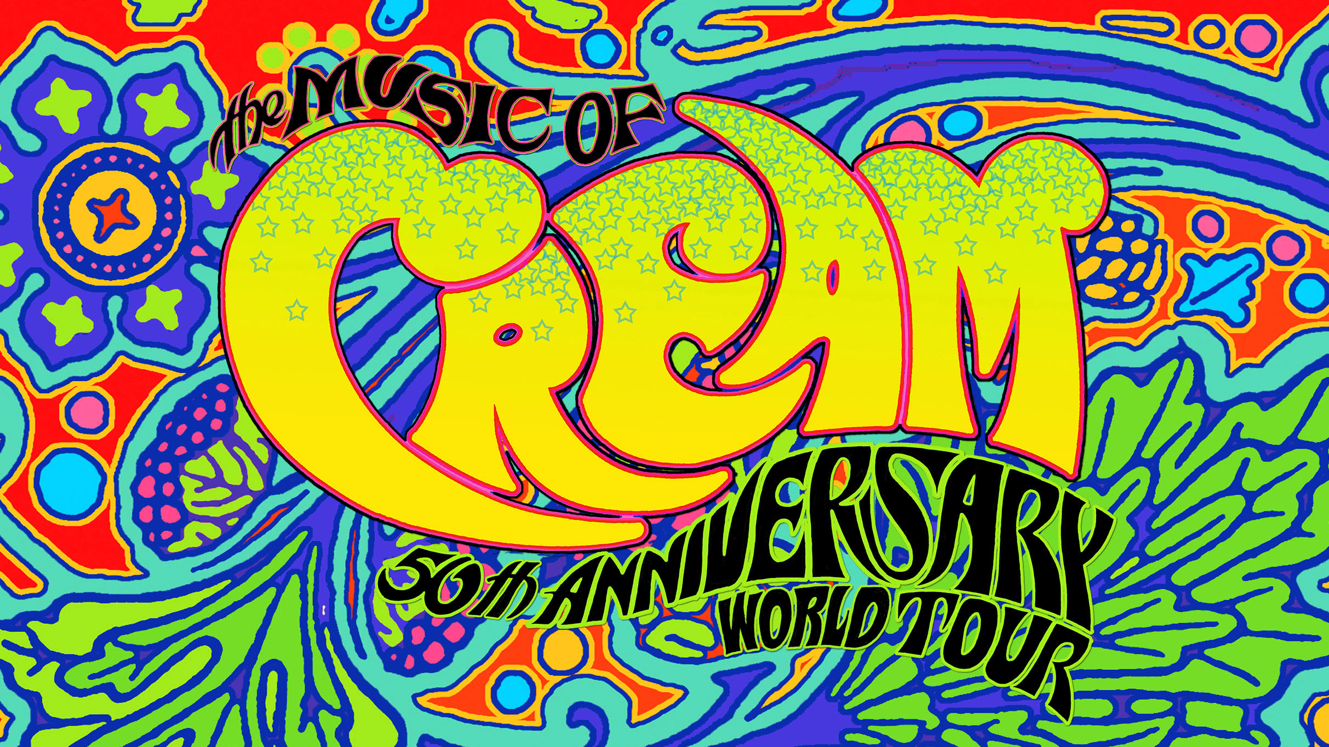

THE MUSIC OF CREAM:
50TH ANNIVERSARY WORLD TOUR

--FEATURING KOFI BAKER, MALCOLM BRUCE AND WILL JOHNS--
TO TOUR ACROSS NORTH AMERICA THIS FALL
LAUNCHING SEPTEMBER 28 IN OTTAWA

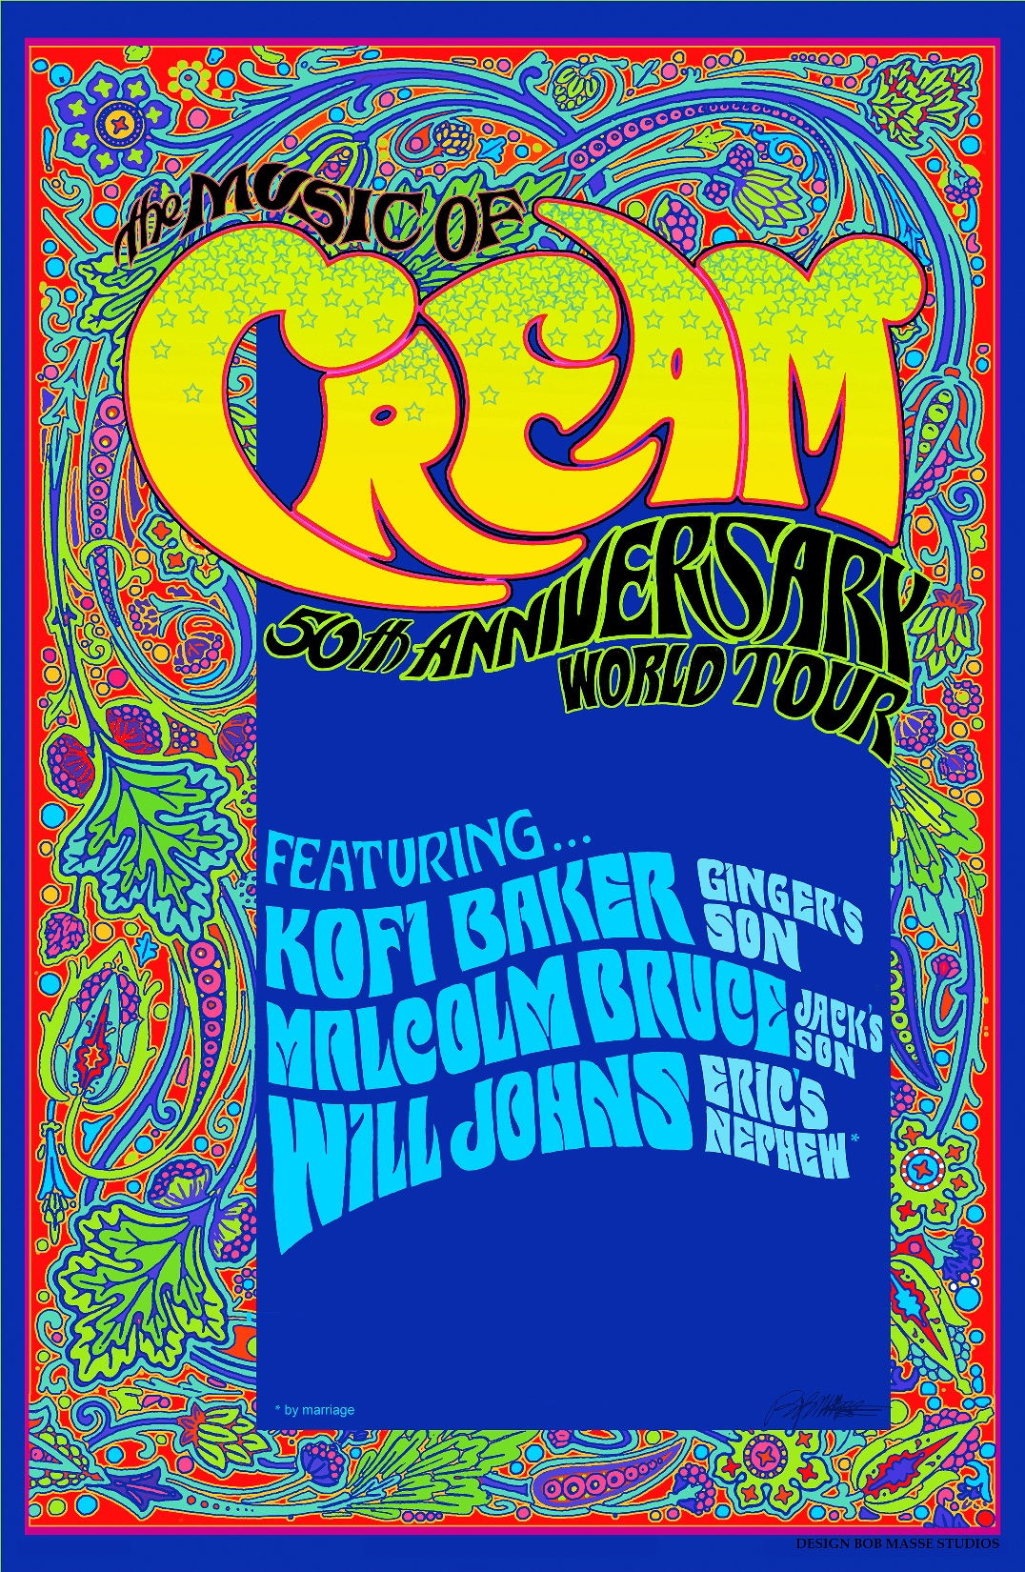
Artwork created by Bob Masse

Following their successful inaugural tour across Australia and New Zealand in 2017, the pedigree of hallowed ‘60s trio Cream—Ginger Baker’s son KOFI BAKER, Jack Bruce’s son MALCOLM BRUCE and Eric Clapton’s nephew* WILL JOHNS—have come together for the first time in North America to pay homage to the band’s extraordinary legacy with THE MUSIC OF CREAM - 50TH ANNIVERSARY WORLD TOUR. The eight-week outing—kicking off September 28 in Ottawa and spanning 34 cities throughout North America this fall—will mark 50 years since the original lineup’s farewell U.S. tour of 1968.

Click HERE to watch the trailer for THE MUSIC OF CREAM – 50TH ANNIVERSARY WORLD TOUR.

Having received rave reviews in Australia and New Zealand from the media and fans alike, THE MUSIC OF CREAM – 50TH ANNIVERSARY WORLD TOUR is primed to take over North America and celebrate the music and legacy their family members created. Prepare to hear personal stories and songs such as “Sunshine of Your Love,” “Crossroads,” “Spoonful” and “White Room” performed across a comprehensive set, which will also see BAKER (drums), BRUCE (bass, vocals) and JOHNS (guitar, vocals) interplay with footage of their fathers and mentors on the big screen, along with never-before-seen footage and photos. This multi-media concert experience has been specially created for the 50th Anniversary Tour, providing some of rock’s most memorable moments with a new lease on life.

“We had such an amazing response to our first tour in Australia and New Zealand that we’ve spent some considerable time adding to the show,” shares BRUCE. “Now, we not only have this amazing legacy of music to play, but an opportunity to share some wonderful insights and stories with our audience…a backstage pass like no other, if you will.”

Adds BAKER, “We also have a few surprises in store that we know people are going to really respond to, so we can’t wait to be on the road again playing these shows across North America this fall.”

After the Ottawa launch, the first leg of THE MUSIC OF CREAM – 50TH ANNIVERSARY WORLD TOUR will travel throughout Eastern Canada and Eastern and Midwest USA stopping in such places as Montreal, Quebec City, Portland, New London, Englewood, Huntington, Philadelphia, Albany, Harrisburg, Baltimore, Pittsburgh, Cleveland, Indianapolis, Des Moines, Milwaukee, Madison and Louisville, among many others, before wrapping November 16 in Cincinnati. See below for full North American tour routing. For ticketing information, go to www.musicofcream.com.

In addition, look for the announcement of four celebratory shows across the U.K. coming soon, coinciding with the anniversary of the original band’s legendary Albert Hall farewell concert, November 26, 1968, ahead of a nationwide tour in the spring.

Of the tour’s run of shows in Australia and New Zealand, which featured special guests Glenn Hughes and Robben Ford, The RockPit noted, “Eric and Ginger and Jack (if looking down on us) would be proud. This is an exceptional night of wonderful music” with The Music adding, “The Music of Cream were not trying to emulate their free-spirited forefathers…this was purely about celebrating the legendary music.” Elsewhere, Ambient Light said, “The trio took turns supporting one-another with bluesy riffs and bursting out in energetic solos. Be it through Baker’s pounding bursts during ‘Sitting on the Top of the World,’ Bruce’s jazzy climbs throughout ‘Politician,’ or the shreds and wails of Johns in ‘Deserted Cities,’ the group had the audience eating out of the palm of their hands.”

During its heartbreakingly short lifespan, Cream was an explosive musical cocktail that provided the super-group blueprint for others to follow. The group’s third album, Wheels of Fire (1968), was the world’s first platinum-selling double album, and collectively they sold more than 15 million copies of their albums worldwide. Not surprisingly, Rolling Stone ranked the Rock and Roll Hall of Fame group (inducted in 1993) as 67th in their ‘100 Greatest Artists of All Time’ list.

Apart from an equally brief reunion in 2005 of seven shows at London’s Royal Albert Hall and New York’s Madison Square Garden, Cream retained an almost mythological status in the music world, right up until the passing of Jack Bruce in 2014. This, for many fans, marked the end of an era and an acceptance that there would never really be another opportunity to celebrate the group’s legacy. That is, until the MUSIC OF CREAM – 50TH ANNIVERSARY WORLD TOUR hit Australia and New Zealand last year.

Now, the trio of BAKER, BRUCE and JOHNS are looking forward to inspiring and re-igniting North America with their very own celebration of a musical legacy that runs through their veins.

*by marriage

The Music of Cream – 50th Anniversary North American Tour Dates:

DATE CITY VENUE
Fri 9/28 Ottawa, ON Centrepoint Theatre
Sat 9/29 Montreal, QC Corona Theatre
Sun 9/30 Quebec City, QC Imperial Bell
Tue 10/2 South Burlington, VT Higher Ground
Thu 10/4 Ridgefield, CT Ridgefield Playhouse
Fri 10/5 Woonsocket, RI Stadium Theatre
Sat 10/6 New Bedford, MA Zeiterion Theatre
Sun 10/7 Portland, ME State Theatre
Tue 10/9 Northampton, MA Calvin Theatre
Thu 10/11 Lynn, MA Lynn Memorial Auditorium
Fri 10/12 New London, CT Garde Arts Center
Sat 10/13 Concord, NH Capitol Centre for the Arts – Chubb Theatre
Sun 10/14 Jim Thorpe, PA Penn’s Peak
Tue 10/16 Englewood, NJ Bergen Performing Arts Center
Wed 10/17 Huntington, NY The Paramount
Thu 10/18 Glenside, PA Keswick Theatre
Fri 10/19 Waterloo, NY The Vine at del Lago Casino
Sun 10/21 Albany, NY Hart Theatre Empire State Plaza PAC “The Egg”
Tue 10/23 Red Bank, NJ Count Basie Theatre
Wed 10/24 Harrisburg, PA Stage @ Club XL
Thu 10/25 Baltimore, MD Rams Head Live
Fri 10/26 Greensburg, PA Palace Theatre
Thu 11/1 Cleveland, OH Playhouse Square – State Theatre
Fri 11/2 Newark, OH Midland Theatre
Sat 11/3 Indianapolis, IN The Vogue
Wed 11/7 Des Moines, IA Des Moines Performing Arts Center
Thu 11/8 St. Charles, IL Arcada Theatre
Fri 11/9 Milwaukee, WI Pabst Theater
Sat 11/10 Cedar Rapids, IA Paramount Theatre
Sun 11/11 St. Paul, MN Fitzgerald Theatre
Tue 11/13 Wausau, WI Grand Theater
Wed 11/14 Madison, WI Orpheum Theater
Thu 11/15 Louisville, KY Brown Theatre
Fri 11/16 Cincinnati, OH Bogarts

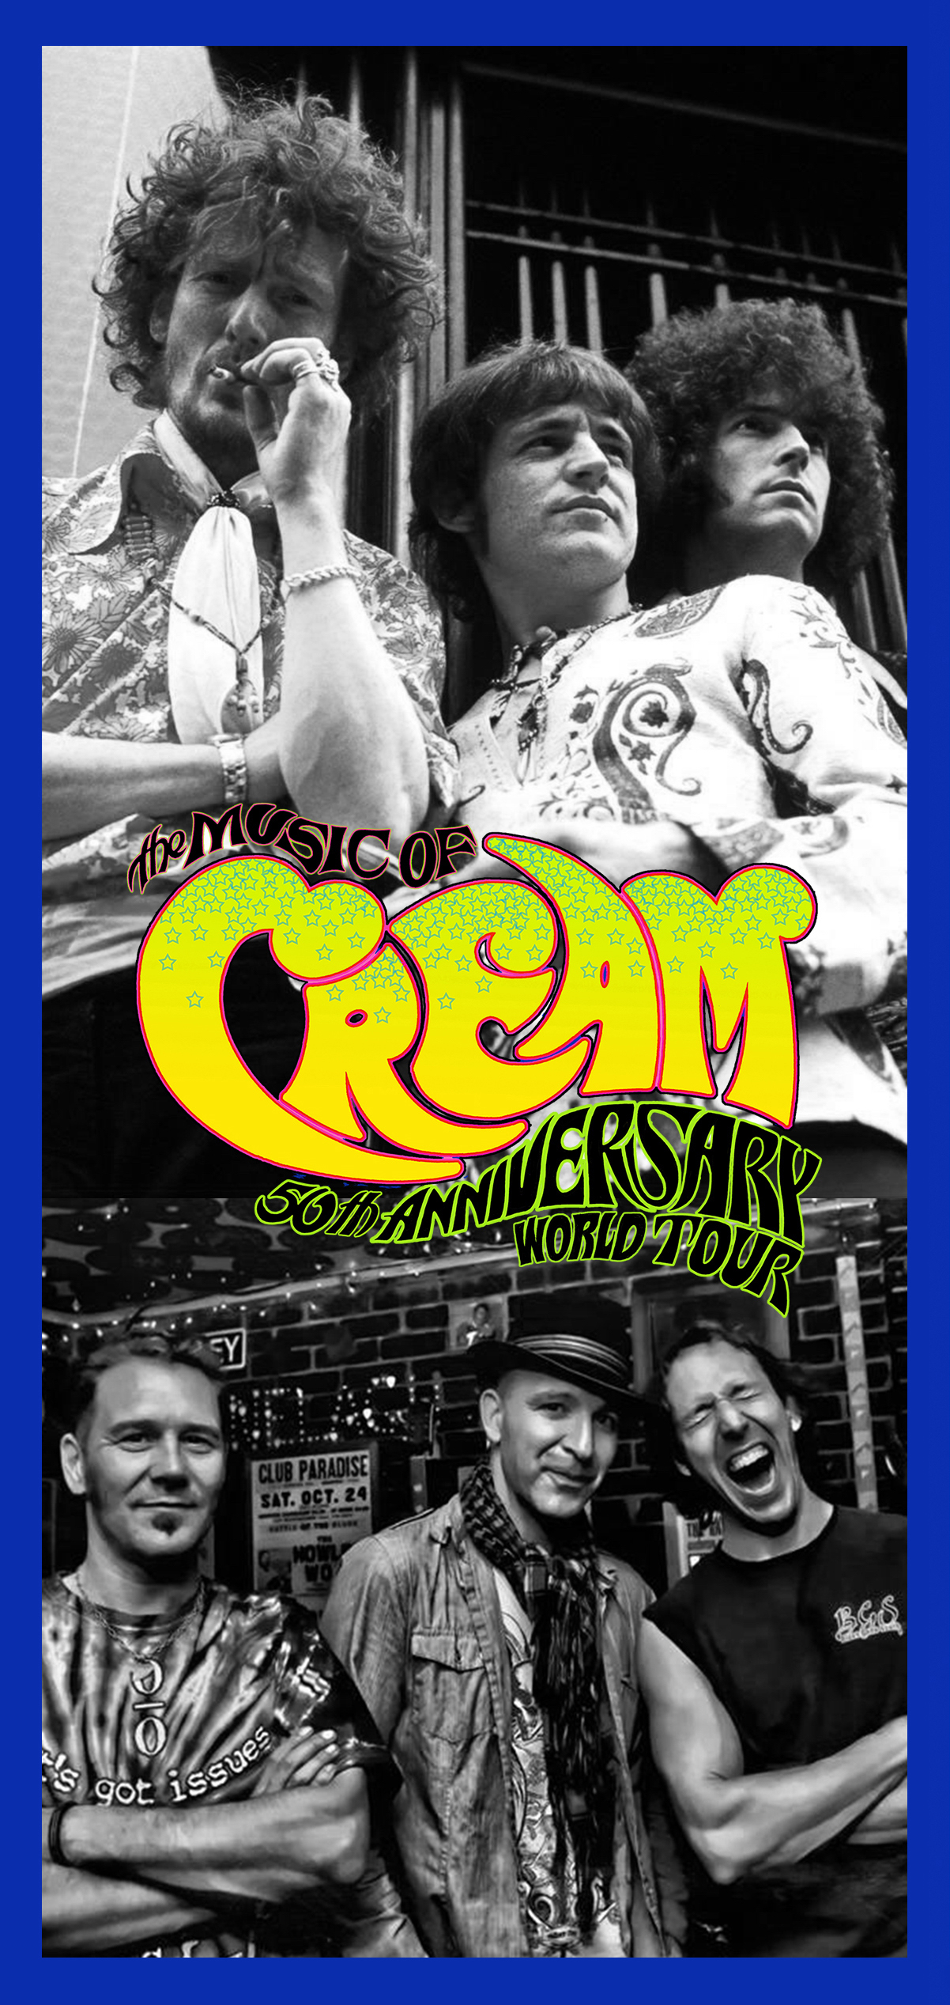

https://www.musicofcream.com
https://www.facebook.com/Musicofcream

MSO Press Releases + Assets

###

For more information on THE MUSIC OF CREAM – 50TH ANNIVERSARY WORLD TOUR, contact MSO PR:
Mitch Schneider mschneider@msopr.com
Bari Lieberman blieberman@msopr.com

For booking inquiries, contact SRO Artists, Inc.:
John Schimmelman jschimmelman@sroartists.com
Jeff Laramie jlaramie@sroartists.com

