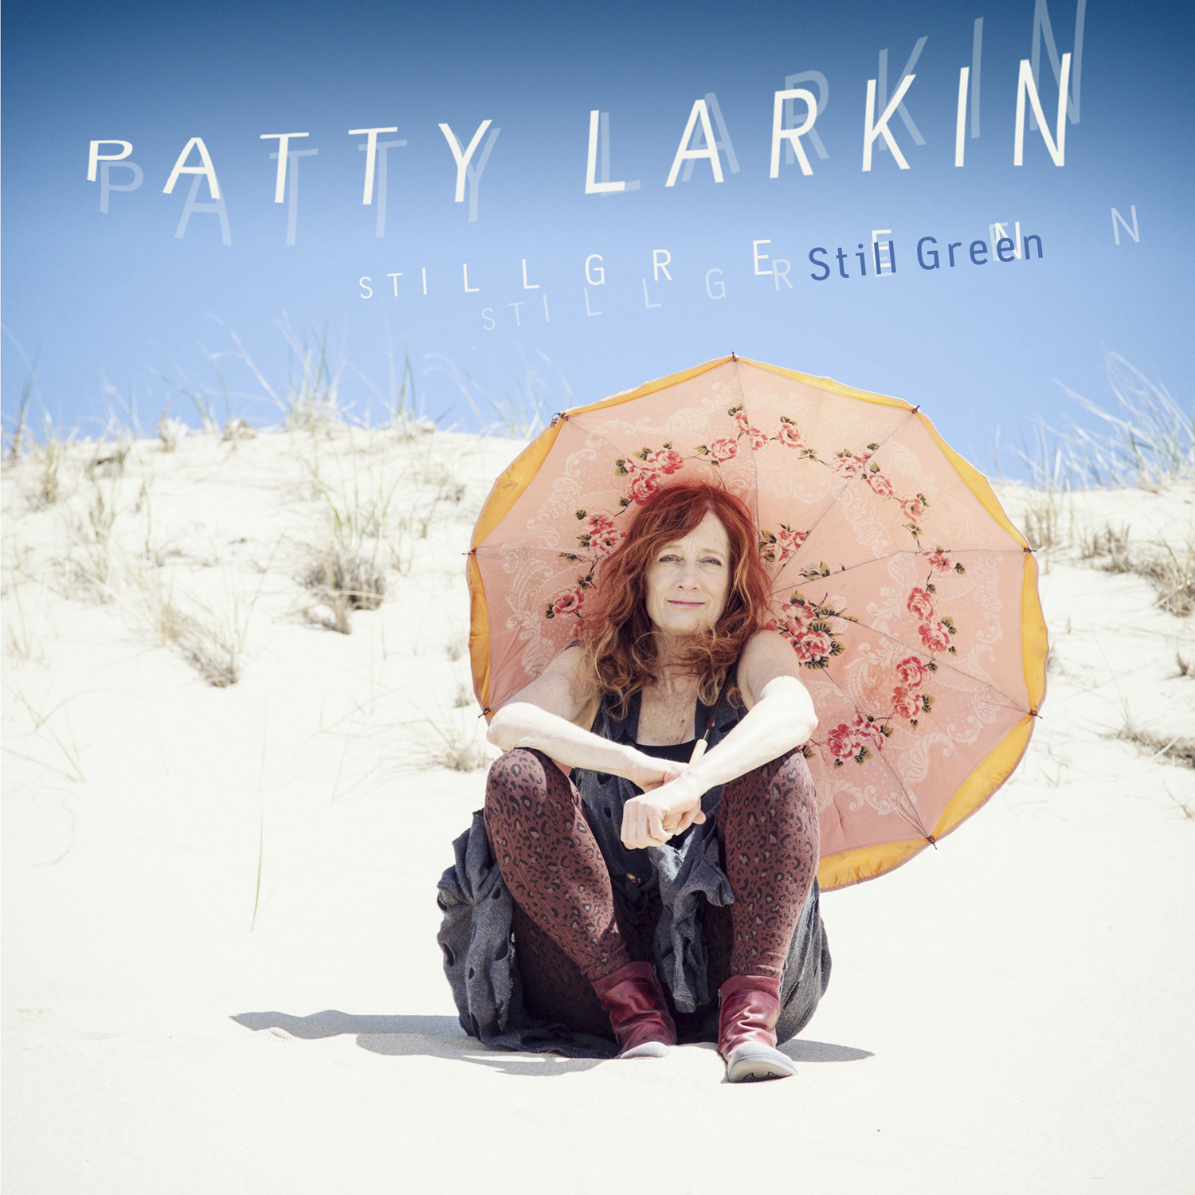
Patty Larkin

STILL GREEN
©2013 Signature Sounds Recordings / www.signaturesounds.com

Patty Larkin redefines the boundaries of folk-urban pop music with her inventive guitar wizardry and uncompromising vocals and lyrics. Acoustic Guitar hails her “soundscape experiments” while Rolling Stone praises her “evocative and sonic shading.” She has been described as “riveting” (Chicago Tribune), “hypnotic” (Entertainment Weekly) and a “drop-dead brilliant” performer (Performing Songwriter ).

Patty Larkin’s new release Still Green, her 13th recording, is co-produced with Mike Denneen (Aimee Mann, Howie Day). Still Green plays out in Technicolor sound images, a kaleidoscope of sun and sea traveling from the fluorescent-lit hallways of grief to the warm pull of love, family and nature. Much of it written in a primitive dune shack on the Outer Banks of Cape Cod’s National Seashore, Still Green is a fresh approach to sound and life from a legendary songwriter who continues to amaze.

Patty’s previous release, 25, celebrated a quarter century of music making with a 25-song, career retrospective reworked with voice and guitar and 25 friends. Among them, Grammy winners (Rosanne Cash, Suzanne Vega, Shawn Colvin, Janis Ian), and a veritable who’s-who of singer songwriters (Bruce Cockburn, Martin Sexton, Dar Williams, Greg Brown, Mary Chapin Carpenter), and others.

www.pattylarkin.com

NOTABLE QUOTES
Critics Choice NY Times

Riveting Chicago Tribune
One of the most gifted performers in music today

Wild Perfection Boston Globe
Patty Larkin transmits eccentric magic

Triple Threat Billboard
An absolutely stunning guitarist, Larkin matches her instrumental chops as a vocalist & songwriter

Genre Stretching String Popping Alterna-folk Guitar World

